Goran Angelov curriculum VITAE (last update July 2015)

Name | Goran Angelov
Department | National and Regional Security,  University of National and World Economy (UNWE), Sofia, Bulgaria
Telephone  Fax | +359 2 8195298,  +359 2 8195272
E-mail | Gangelov29@e-dnrs.org
Work description | Phd Student
Picture | 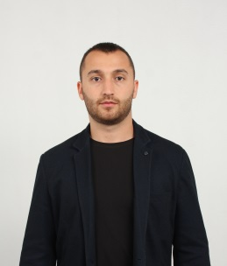
Working fields | Economics of defense and security, Economics security
CV (Short) | Since 2015 Phd Student, University of National and World Economy, Sofia, Bulgaria  Since 2013 Technical assistant in Bulgarian Academy of science (Institute of Metal Science, equipment, and technologies “Acad. A. Balevski” with Center for Hydro- and Aerodynamics)
Homepage | www.unwe.bg  www.e-dnrs.org
Postal address | University of National and World Economy  Studentski grad 1700  Sofia  Bulgaria

CV Goran Angelov (Long) with Publications (last update July 2015)
CURRICULUM VITAE (long)
1. General Information

Personal Information
Name: Goran Angelov
Work Address: University of National and World Economy, Studentski grad, Sofia, 1700, Bulgaria
Work Tel: +359-2-8195 298
Work Fax: +359-2-8195 272
E-Mail: gangelov29@e-dnrs.org

Languages:

Bulgarian: native
English: fluent
French: fluent
Research Interests
Defense economic
Economic security
2. Education, Honours and Career

Education
University for National and World Economy – Sofia 2013-2014 Economy of defense and security (Master)

University for National and World Economy – Sofia 2009-2013 Economy of defense and security (Bachelor)

Work Experience
Date from - Date to | Location | Company / Organisation | Position/description
from 10.2013 till present | Sofia, Bulgaria | Bulgarian Academy of science (Institute of Metal Science, equipment, and technologies “Acad. A. Balevski” with Center for Hydro- and Aerodynamics) | Technical assistant

