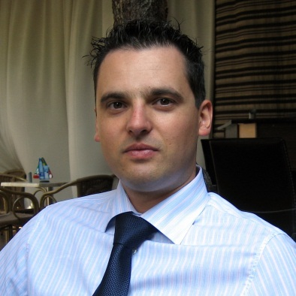 | Curriculum Vitae  of  Danail Georgiev

Education and training:
From 1991 to 1996 г. – Foreign Language School in Lovetch, German and English languages;
From 1997 to 1998 – Military school for reserve officers “Hristo Botev”, Pleven, Platoon commander;
From 1998 to 2003 – Student of International Relations, Sofia University “St. Kliment Ohridsky”, M.A.;
January, 2002 – Educational Practice – “Strategy and Analyses” Department, “Defence Planning” Directorate, Ministry of Defence of the Republic of Bulgaria;
From March to July 2005 – International Parliamentary Practice in Deutscher Bundestag (Federal German Parliament), Assistant in the bureau of Rolf Kramer, MdB (SPD), Defence committee, Petitions committee;
From 2008 to 2011 – Participant at the Parliamentary Staff Advisers Training Program of the Geneva Centre for the Democratic Control of the Armed Forces;
From 2012 to 2013 - Participant at the DCAF Framework Project - Fostering Parliamentary Oversight of the Security Sector in the Western Balkans.

Additional Qualifications, courses, specializations etc.:
July, 2004 – European Academy for Security Policy 2004 – Training seminar, Austrian Institute for European Security Policy;
July, 2007 – VII European Young Leaders Conference of Atlantik-Brücke e.V., since then member of the Young Leaders Network of Atlantik-Brücke e.V.;
April, 2009 – US-European Security, International Visitor Leadership Program, State Department, USA
June, 2010 – Leading, Innovating, and Negotiating: Critical Strategies for Public Sector Executives, Course, Harvard Kennedy School;
April, 2011 – Forms of Cooperation between Administration, Citizen’s and Business Organization, Course, Institute for Public Administration.

Work experience:
From November 2002 – September 2005 – Supreme Council of the Bulgarian Socialist Party, Directorate “Parliamentary activities”. Responsibilities: Expert assistance of the Members of Parliament in: Foreign Policy and International Relations, International Security, European Integration. Observing the activities in the Foreign Policy, Defence and Security Committee and European Integration Committee.
From September 2005 – August 2009 – National Assembly of the Republic of Bulgaria, Defence Committee, Senior Expert. Responsibilities: Support of the legislative, oversight and representative activities of the Committee by doing: research and analyse of information, work out professional evaluation, positions, reports, amendments, draft laws and others on issues in the field of the security and defence policy.
From August 2009 – to June 2013 – National Assembly of the Republic of Bulgaria, Foreign Affairs and Defence Committee, Chief Expert. Responsibilities: Support of the legislative, oversight and representative activities of the Committee by doing: research and analyse of information, work out professional evaluation, positions, reports, amendments, draft laws and others on issues in the field of the international affairs, security and defence policy. Management of the Student-Training program of the Committee.
From June 2013 – to July 2013 – Ministry of Defence of the Republic of Bulgaria, Parliamentary Secretary. Responsibilities: Member of the Political Cabinet, managing the parliamentary activities of the ministry. Planning, preparing and coordination of oversight, legislative and other official business in the parliament. Liaison with Members of Parliament of various parties and groups represented in Parliament. Advice to the minister on procedural and other parliamentary matters.

Language skills:
German – very good
English – very good

